How do apps interact with Kernel? -> using system calls.
Eg. Mkdir laks
- Mkdir indirectly calls kernel and asked the file mgmt. module to create a new
directory.
- Mkdir is just a wrapper of actual system calls.
- Mkdir interacts with kernel using system calls.
Eg. Creating a process.
- User executes a process. (User space)
- Gets system call. (US)
- Exec system call to create a process. (KS)
- Return to US.
Transitions from US to KS done by software interrupts.
System calls are implemented in C.
A system call is a mechanism using which a user program can request a service from the kernel for
which it does not have the permission to perform.
User programs typically do not have permission to perform operations like accessing I/O devices and
communicating other programs.
System Calls are the only way through which a process can go into kernel mode from user mode.
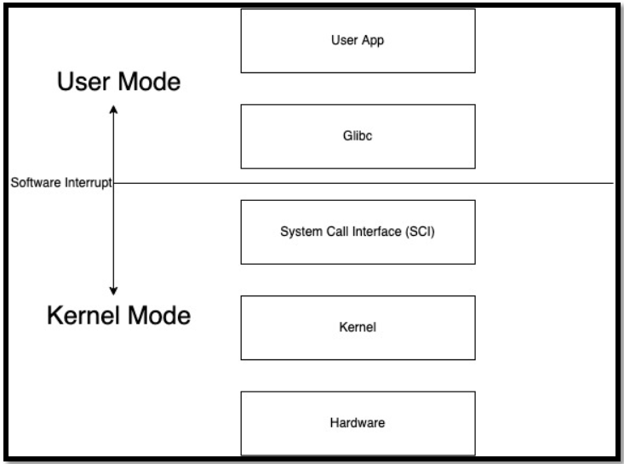
Types of System Calls:
1) Process Control
a. end, abort
b. load, execute
c. create process, terminate process
d. get process attributes, set process attributes
e. wait for time
f. wait event, signal event
g. allocate and free memory
2) File Management
a. create file, delete file
b. open, close
c. read, write, reposition
d. get file attributes, set file attributes
3) Device Management
a. request device, release device
b. read, write, reposition
c. get device attributes, set device attributes
d. logically attach or detach devices
4) Information maintenance
a. get time or date, set time or date
b. get system data, set system data
c. get process, file, or device attributes
d. set process, file, or device attributes
5) Communication Management
a. create, delete communication connection
b. send, receive messages
c. transfer status information
d. attach or detach remote devices
